TASK 1: Weather App (Draw the Flowchart, then Code)

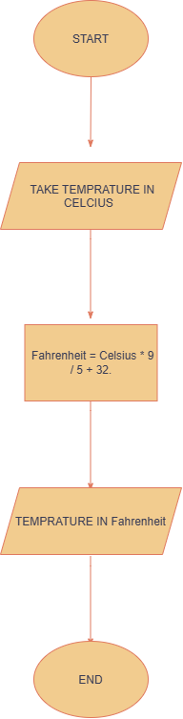
TASK 2: Cinema Ticket (Reading a Flowchart with a Decision)
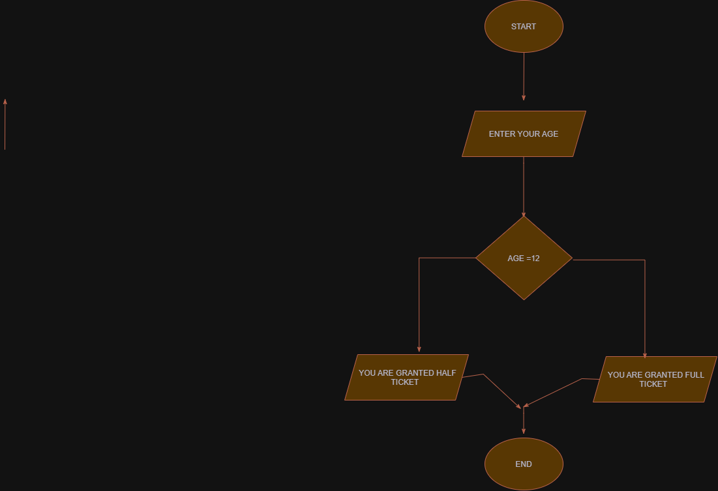

No. | Age (Age<12) | Condition | Ticket Printed
1 | 12 | TRUE | HALF
2 | 13 | FALSE | FULL
3 | 14 | FALSE | FULL

